WEEK 4

An Attack Scenario

***Assess Risk***

* Quantitative to calculate the impact to business if credit card info is stolen, **SLE**, **ALE**.
* Single Loss Expectancy (**SLE**).
* Annualised Loss Expectancy (**ALE**).

***Qualitative***

* A group of experts to identify the severity, probability and impact of a threat (*Steal credit card info*).
* calculate **ROSI** for countermeasures (*Return on Security Investment* (**ROSI**)).

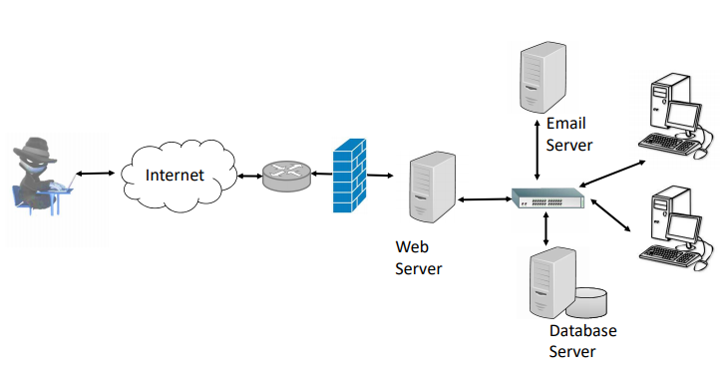

Handle Risk – **Mitigate**, **Accept**, **Transfer** or **Avoid.**

Risk Assessment Methodologies

Different Standards to assess risk:

* NIST 800-30
* FRAP
* OCTAVE
* ISO/IEC 27005
* AS/NZS 4360
* CRAMM

NIST 800-30 Risk Management Guide for Information Technology Systems

*It lays out the following steps:*

1. **System characterization**
2. **Threat identification**
3. **Vulnerability identification**
4. **Control analysis**
5. **Likelihood determination**
6. **Impact analysis**
7. **Risk determination**
8. **Control recommendations**
9. **Results documentation**

NIST 800-30 System characterization

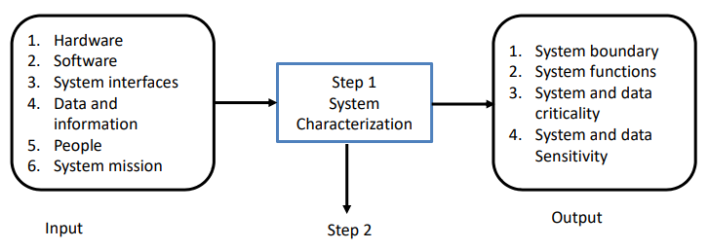

NIST 800-30 System characterization

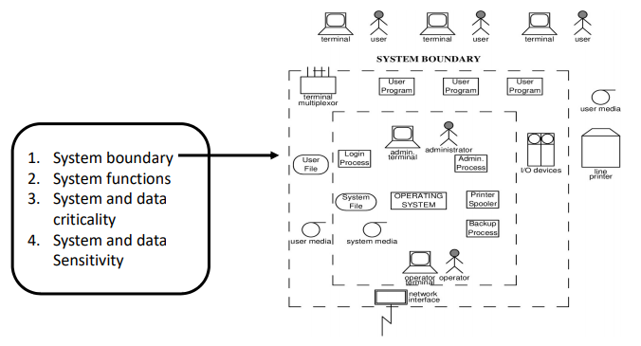

NIST 800-30 Threat Identification

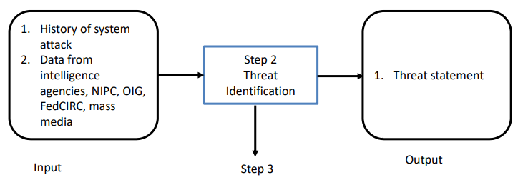

NIST 800-30 Vulnerability Identification

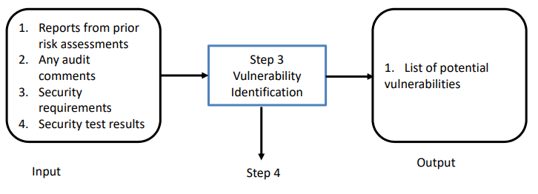

**Sources**

1. Security Focus (*www.securityfocus.com*) searchable databases of vulnerabilities and relevant news groups.
2. Incidents.org (*www.incidents.org*) - information on current threat activities.
3. Packet Storm (*packetstormsecurity.org*)
4. InfoSysSec (*www.infosyssec.com*)
5. SANS ([*www.sans.org*](http://www.sans.org))

**Security Test**

1. Service pack levels
2. Port scanning
3. Services running
4. Wireless leakage
5. Operating system type
6. Intrusion detection testing
7. Network applications running
8. Physical location of the systems
9. Firewall testing
10. Access control permissions.
11. Network Surveying

NIST 800-30 Control Analysis

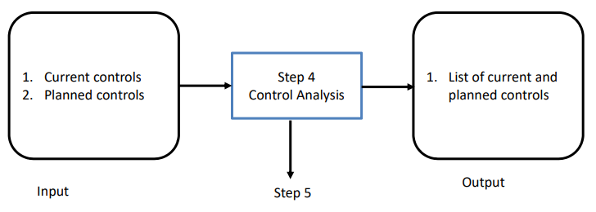

NIST 800-30 Likelihood Determination

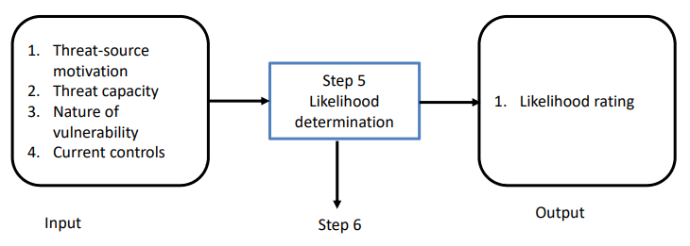

NIST 800-30 Impact analysis

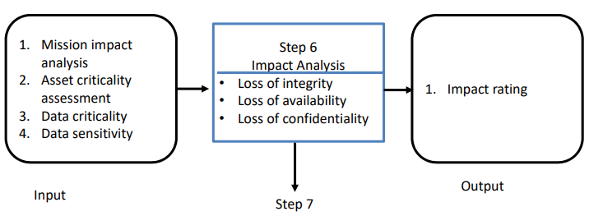

NIST 800-30 Risk determination

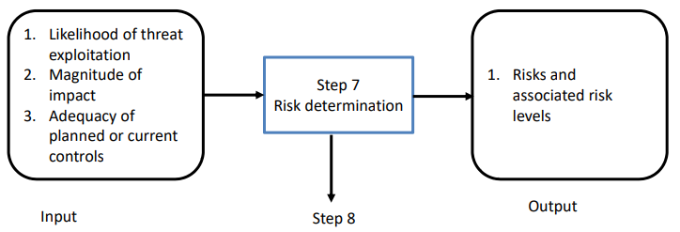

NIST 800-30 Control & Results Recommendations

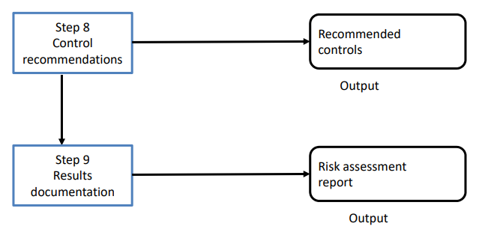

Facilitated Risk Analysis Process (FRAP)

* It is a qualitative methodology.
* It focuses on the systems that really need assessing to reduce costs and time obligations.
* It is to be used to analyse one system, application, or business process at a time.
* Data is gathered and threats to business operations are prioritized based upon their criticality.
* A brainstorming session to list threats.
* The assignment of a simple probability (i.e. **High/Medium/Low**) to each threat.
* The assignment of simple impact (i.e. **High/Medium/Low**) to each threat
* The identification of controls for the listed threats, and a management summary.
* The FRAP users believe that additional effort to develop precisely quantified risks are not cost effective because:
  + Such estimates are time consuming.
  + Risk documentation becomes too voluminous for practical use.
  + Specific loss estimates are generally not needed to determine if controls are needed.
* Each risk analysis session takes approximately **4 hours** and Includes **7 to 15 people**.
* Team does not attempt to obtain or develop specific numbers for threat likelihood or annual loss estimates but to sets priorities.
* After identifying and categorizing risks, the groups identifies controls that can be implemented to reduce the risk.
* The Team’s conclusions as to what risks exist and what controls are needed are documented along with a related action plan for control implementation.

Spear Phishing Case Scenario

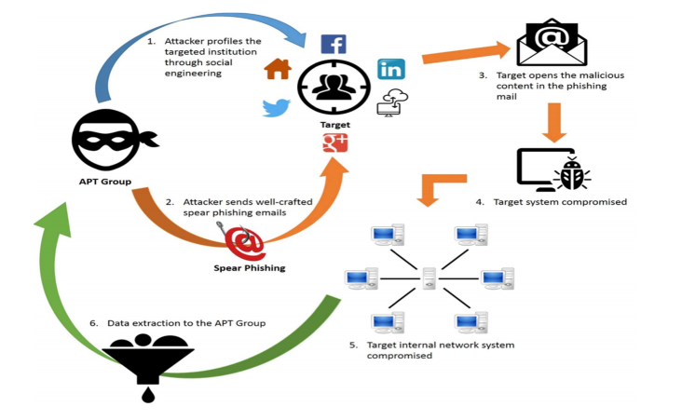

Prioritizing Risk – Qualitative

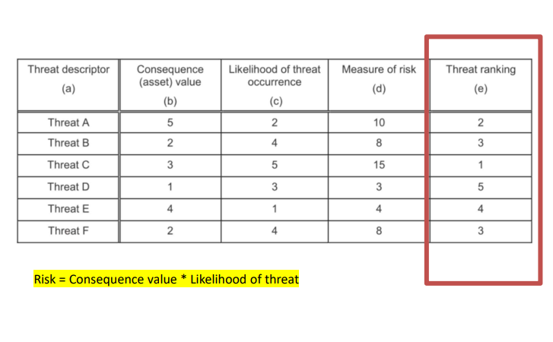

Operationally Critical Threat, Asset, and Vulnerability Evaluation (OCTAVE)

* Created by Carnegie Mellon University’s Software Engineering Institute.
* The method is performed in a series of workshops conducted and facilitated by an interdisciplinary analysis team.
* The intended audience for the OCTAVE method is large organizations with 300 or more employees.
* Identify assets that are important to the mission of the organization.
* Identify vulnerabilities and threats to those assets.
* Determine and evaluate the potential consequences to the organization if threats are realized.

Three OCTAVE Method Phases

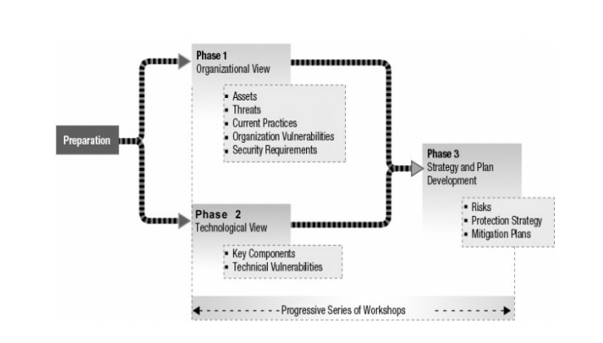

OCTAVE Allegro

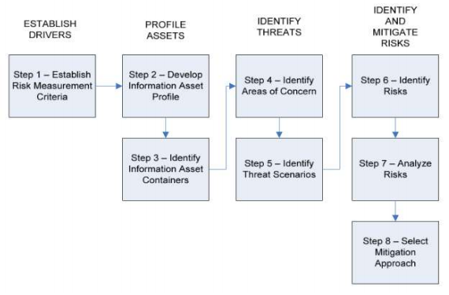

OCTAVE Allegro

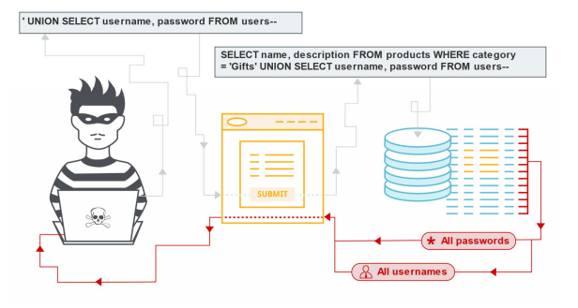

OCTAVE Allegro

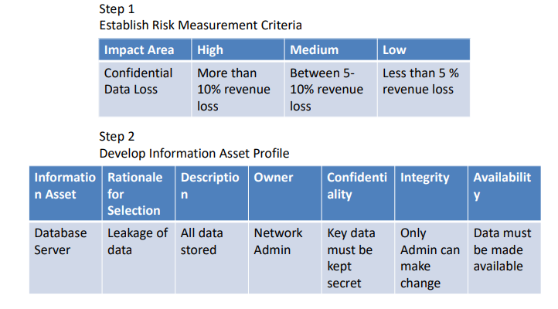

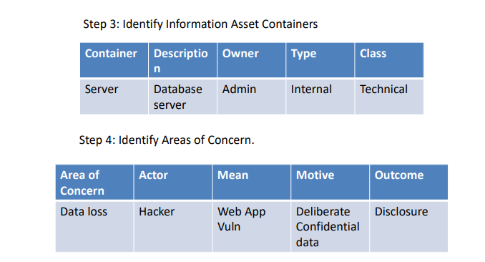

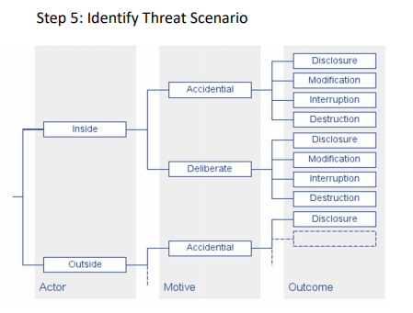

OCTAVE Allegro

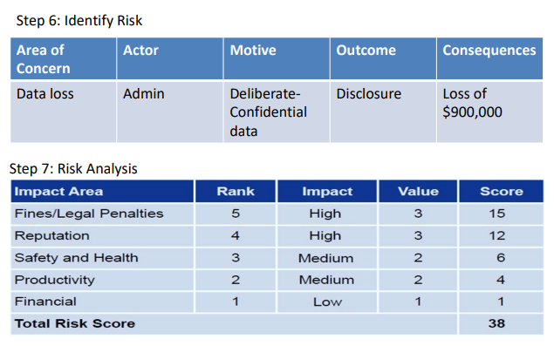

Step 8: Mitigation Approach

1. **Mitigate**
2. **Avoid**
3. **Transfer**
4. **Accept**

ISO/IEC 27005

1. Identification of assets.
2. Identification of legal and business requirements that are relevant for the identified assets.
3. Valuation of the identified assets, taking account of the identified legal and business requirements and the impacts of a loss of confidentiality, integrity and availability.
4. Identification of significant threats and vulnerabilities for the identified assets.
5. Assessment of the likelihood of the threats and vulnerabilities to occur.
6. Calculation of risk.
7. Evaluation of risks against a predefined risk scale.

ISO/IEC 27005 – Asset Identification

* The important assets within the scope of the ISMS should be clearly identified and appropriately valued.
* An inventory of these assets should be put together and maintained.
* An owner should be identified for each of the identified assets.

Identification of legal and business requirements

* The unique set of threats and vulnerabilities which could lead to significant losses if they occur.
* The legal, statutory and contractual requirements which are applicable to the organization, its trading partners, contractors and service providers.
* The unique set of principles, objectives and requirements for information processing that an organization has developed t support its business operations and processes.

Asset valuation

* To assess their values in terms of their importance to the business or their potential values in different business opportunities.
* It is also important to take account of the identified legal and business requirements and the impacts resulting from a loss of CIA.
* In order to consistently assess the asset values, a valuation scale for assets should be defined.

Identification and assessment of threats and vulnerabilities

* Implemented controls
* Identification of threats and vulnerabilities
* Threats can originate from accidental or deliberate sources or events.
* A threat would need to exploit one or more vulnerabilities of the systems, applications or services to successfully cause harm to assets.
* Threats may originate from within the organization as well as external to it.
* Deliberate threats.
* Accidental threats.
* Past incidents.
* New developments and trends.

Risk calculation and evaluation

* The risks are calculated from the combination of asset values and the assessed likelihood of related threats and vulnerabilities to come together and cause an incident.
* How the two contributing factors (the impact and the likelihood value) are combined to calculate the risk.
* The results of the risk assessment process should be documented in a risk assessment report.

The risk assessor

* The person who performs the information security risk assessments.
* The person should have a basic understanding of how the business works and the risk appetite of the business.
* They should have practical understanding of a suitable risk assessment method and any associated tools, software or forms.
* They have enough interpersonal skills to obtain the necessary information from the people in the organization and to communicate the results of the risk assessment in a way that is easily understood by decision-making management.
* The person who performs the information security risk assessments.
* The person should have a basic understanding of how the business works and the risk appetite of the business.
* They should have practical understanding of a suitable risk assessment method and any associated tools, software or forms.
* They have enough interpersonal skills to obtain the necessary information from the people in the organization and to communicate the results of the risk assessment in a way that is easily understood by decision-making management.

AS/NZS 4360

* This Australian and New Zealand methodology can be used to understand a company’s financial, capital, human safety, and business decisions risks.
* This risk methodology is more focused on the health of a company from a business point of view, not security.

CRAMM

* Central Computing and Telecommunications Agency Risk Analysis and Management Method was created by the United Kingdom.
* Its automated tools are sold by Siemens.
* It works in three distinct stages:
  + Define objectives
  + Assess risks
  + Identify countermeasures.
* It just has everything (questionnaires, asset dependency modelling, assessment formulas, compliancy reporting) in automated tool format.